Běhací kufr - jobs
- look for the solution - the runners cannot use the searched word
- all words not necessary - the runners can only describe the word

1 2
2 1
3 4
4 2
5 7
6 2
7 2
8 1
9 3
10 1
11 4
12 6
13 2
14 3
15 4
16 4
17 7
18 6
19 6
20 1
21 8
22 2
23 2
24 1
25 5
26 2
27 2
28 6
29 5
30 1
31 2
32 3
33 1
34 2
35 2
36 3

Běhací kufr - jobs
- look for the solution - the runners cannot use the searched word
- all words not necessary - the runners can only describe the word

1 2 SCIENTIST
2 1 HUNTER
3 4 ACTOR
4 2 COACH
5 7 SHOPASSISTANT
6 2 TEACHER
7 2 FARMER
8 1 JOURNALIST
9 3 COOK
10 1 BUTCHER
11 4 LAWYER
12 6 SURGEON
13 2 NURSE
14 3 SOLDIER
15 4 PILOT
16 4 DRIVER
17 7 HAIRDRESSER
18 6 DUSTMAN
19 6 CARPENTER
20 1 DANCER
21 8 BRICKLAYER
22 2 DOCTOR
23 2 MUSICIAN
24 1 WAITRESS
25 5 DENTIST
26 2 PLUMBER
27 2 CLEANINGLADY
28 6 GARDENER
29 5 JUDGE
30 1 VET
31 2 REFEREE
32 3 FIREMAN
33 1 WRITER
34 2 POLICEMAN
35 2 TRANSLATOR
36 3 BAKER

1 | 2
3 | 4
5 | 6
7 | 8
9 | 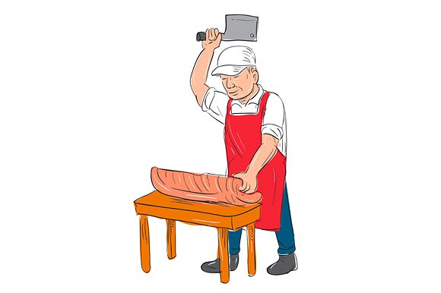  10
11 | 12
13 | 14
15 | 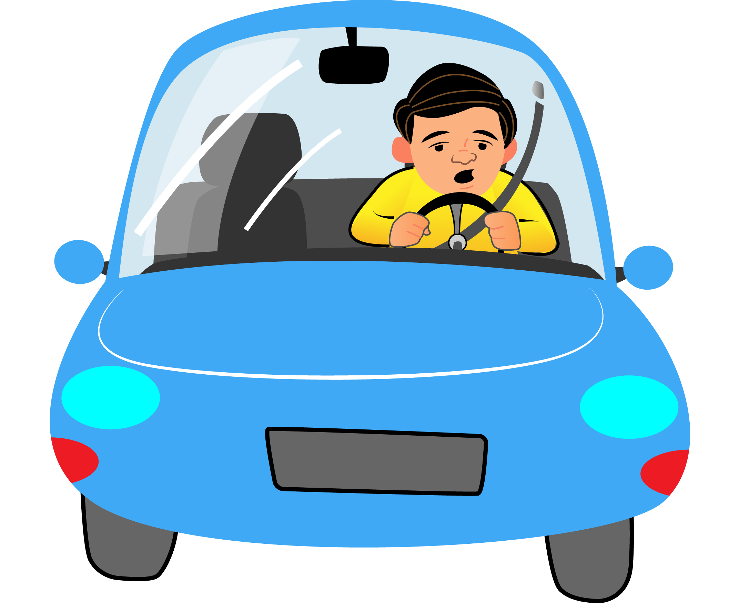  16
17 | 18
19 | 20
21 | 22
23 | 24
25 | 26
27 | 28
29 | 30
31 | 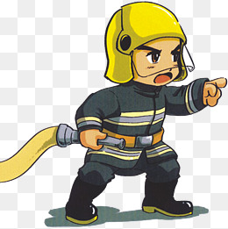  32
33 | 34
35 | 36
1 Scientist | 2 Hunter
3 Actor | 4 Coach
5 Shop assistant | 6 Teacher
7 Farmer | 8 Journalist
9 Cook | 10 Butcher
11 Lawyer | 12 Surgeon
13 Nurse | 14 Soldier
15 Pilot | 16 Driver
17 Hairdresser | 18 Dustman
19 Carpenter | 20 Dancer
21 Bricklayer | 22 Doctor
23 Musician | 24 Waitress
25 Dentist | 26 Plumber
27 Cleaner | 28 Gardener
29 Judge | 30 Vet
31 Referee | 32 Fireman
33 Writer | 34 Policeman
35 Translator | 36 Baker

